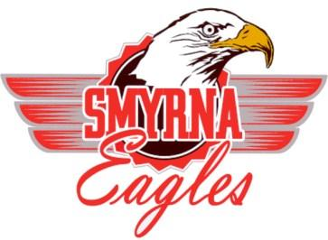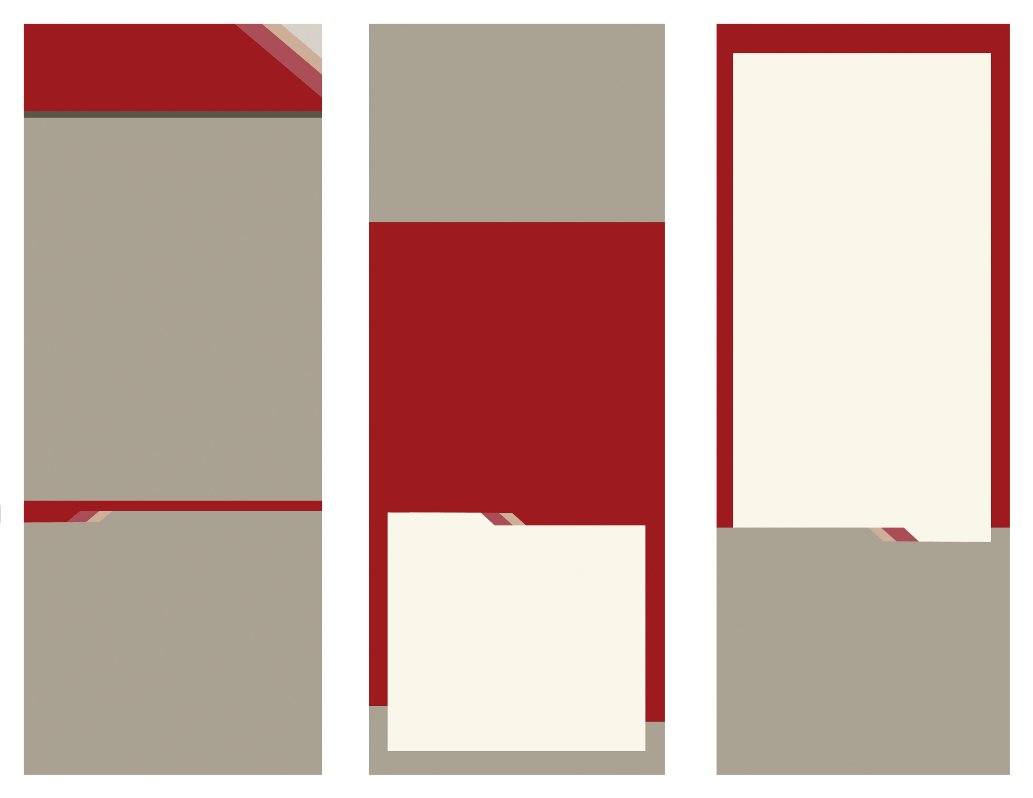

**Why do we have an Appropriate Use Policy (AUP)?**

This policy is in place to protect:

**Technology:**

*Following this policy reduces the risks of viruses and suspicious activity to affect the technology which allows for the best performance.*

**Students:**

*Following this policy creates a safe digital environment for students to learn.*

Smyrna School District

Acceptable Use Policy

A Guide to Understanding Your Rights and Responsibilities to Technology Use

[](http://www.google.com/url?sa=i&rct=j&q=&esrc=s&frm=1&source=images&cd=&cad=rja&docid=-w1ox__yd3MaSM&tbnid=ovI7bw2hIP61wM:&ved=0CAUQjRw&url=http%3A%2F%2Fwww.internationalconnectionsacademy.com%2Fprivate-school%2Four-school%2Fparents%2Fparents-testimonials.aspx&ei=mW2rUd2KGafy0gHg74DABA&bvm=bv.47244034,d.dmQ&psig=AFQjCNGn629lEknTgSRgNXL3ULWkK7kJHg&ust=1370275603373093)

Enter Contact Information Here | 1127 Lombard Blvd. San Francisco, CA 59802 | phone 555.555.5555 | fax 555.555.5555

 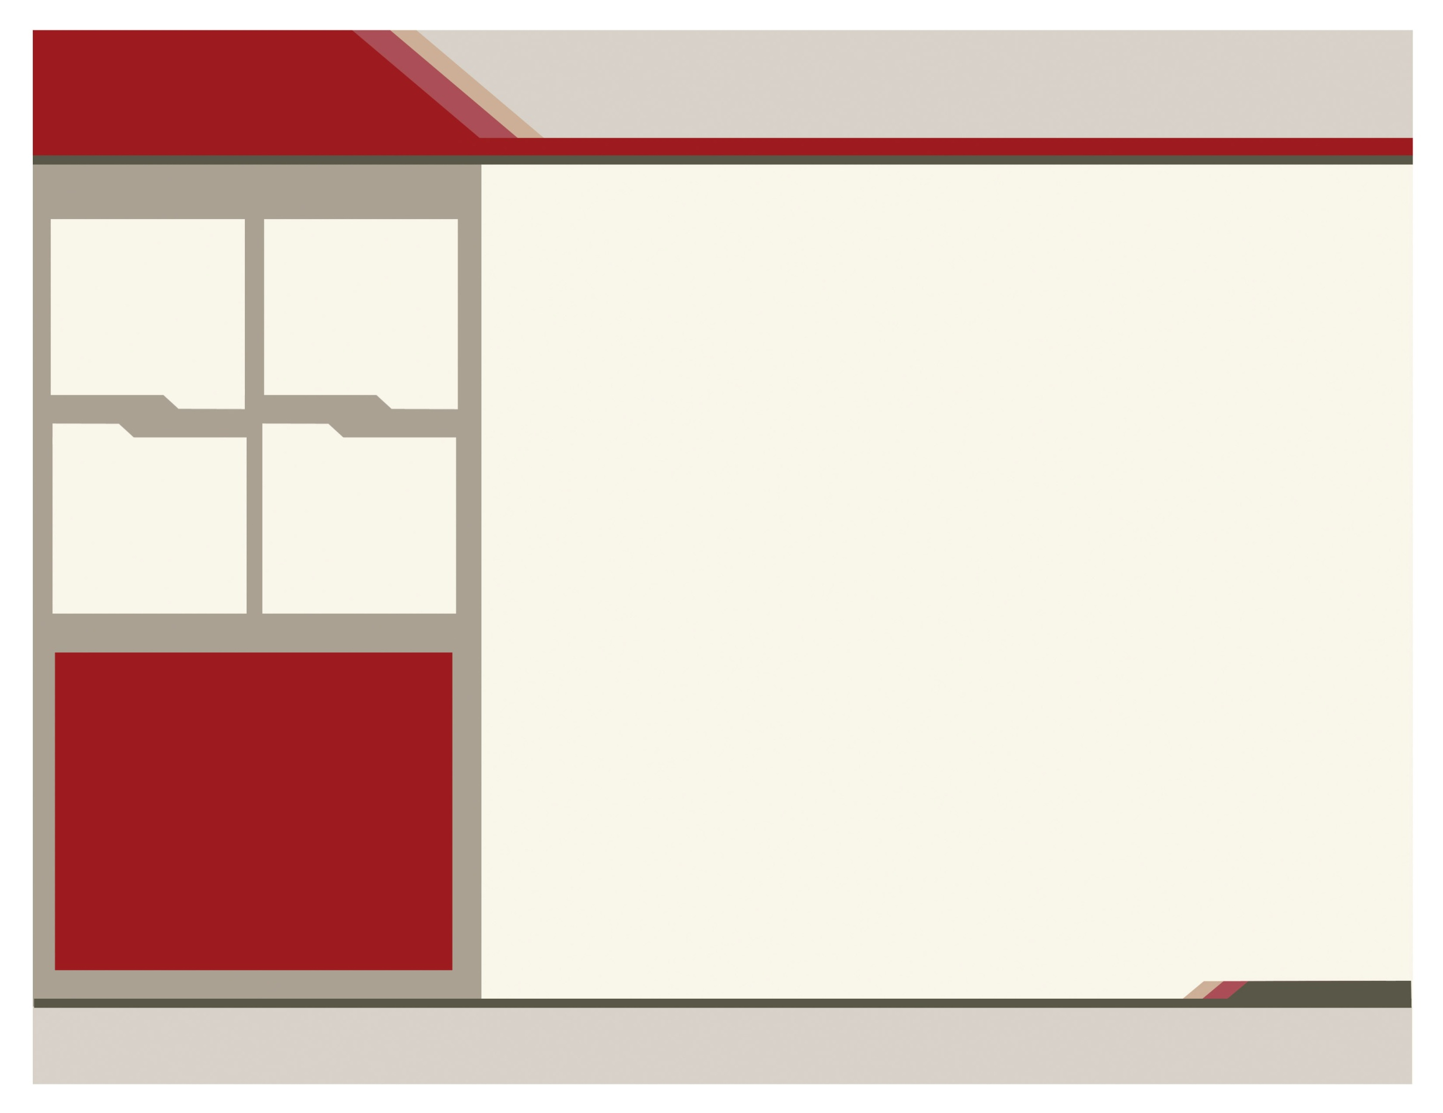

Smyrna School District’s Acceptable Use Policy is adapted from the Delaware Department of Technology and Information.

For More information,

Contact

:

Department of Technology and Information

(302) 739-9500

http://dti.delaware.gov/

Who must abide by the AUP?

* Students
* Teachers
* Administrators
* **Anyone** accessing school computers

**Smyrna School District**

82 Monrovia Avenue

Smyrna, Delaware 19977

(302) 653-8585

Personal Devices (Tablets, laptops, iPods, cell phones, etc) are not allowed in school and will not have access to the school’s Network.

www.smyrna.k12.de.us

**Computer Use may be monitored to ensure Safety of students and technology**

* Using Technology for personal use that interferes with learning, including, but not limited to:
  + Buying items online
  + Listening to streaming music
  + Watching streaming video
  + Downloading music/videos
* Using Technology without teacher permission.
* Accessing Inappropriate Content using the technology
* Using inappropriate language or bullying while communicating through the internet or other technology devices.

**What is Innapropriate use?**

**WHAT IS APPROPRIATE USE?**

* Technology is used for educational activities only.
* Following instructions for use.
* Technology is handled the way they are intended.
* Respect others and technology
* Following School Code of Conduct

CONSEQUENCES

Any student found using a computer for personal use or for purposes other than authorized by a staff member will be subject to disciplinary action and/or suspension of computer privileges.

caption

caption

caption

caption

Delete text and place picture here.

Delete text and place picture here.

Delete text and place picture here.

Smyrna School District

Acceptable Use Policy

Delete text and place picture here.